Practical 4: Configure IP ACLs to Mitigate Attacks
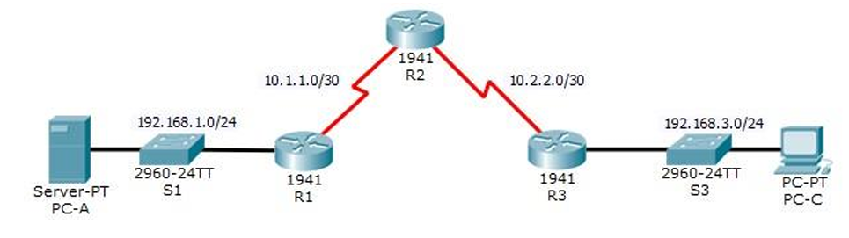
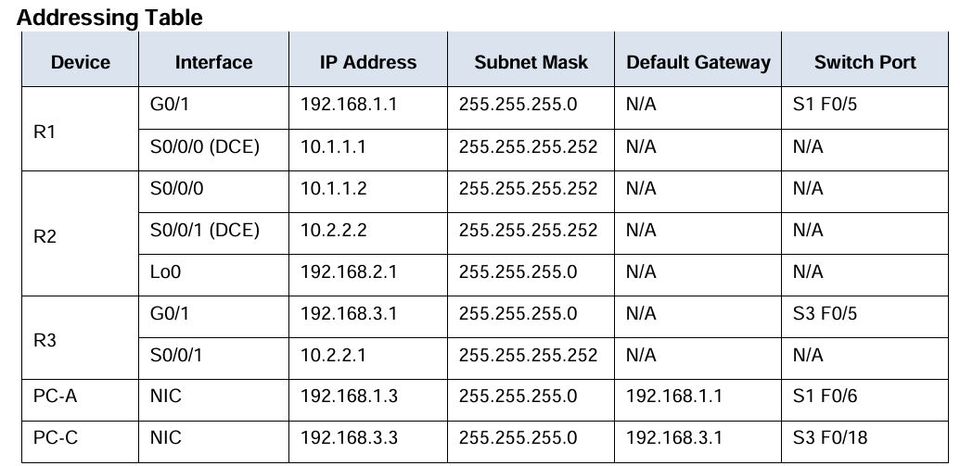

Ip address to loopback 0
Router(config-if)# interface loopback 0
Router(config-if)# ip address 192.168.2.1 255.255.255.0
Routing:
Router(config)#hostname R1
R1(config)#router rip
R1(config-router)#version 2
R1(config-router)#network 10.1.1.0
R1(config-router)#network 192.168.1.0

r2(config)#router rip
r2(config-router)#version 2
r2(config-router)#network 10.1.1.0
r2(config-router)#network 10.2.2.0
r2(config-router)#network 192.168.2.0

Router(config)#hostname R3
R3(config)#router rip
R3(config-router)#version 2
R3(config-router)#network 10.2.2.0
R3(config-router)#network 192.168.3.0

SSH configuration
r2(config)#ip domain-name ccnasecurity.com
r2(config)#username SSHadmin privilege 15 secret ciscosshpa55
r2(config)# line vty 0 4
r2(config-line)# login local
r2(config-line)# transport input ssh
r2(config-line)# crypto key generate rsa

Part 1: Verify Basic Network Connectivity
Step 1: From PC-A, verify connectivity to PC-C and R2.
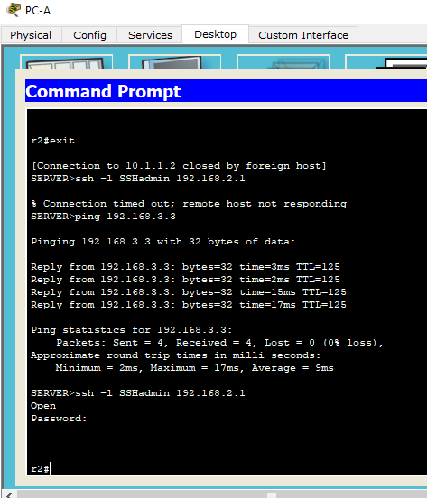
Step 2: From PC-C, verify connectivity to PC-A and R2.
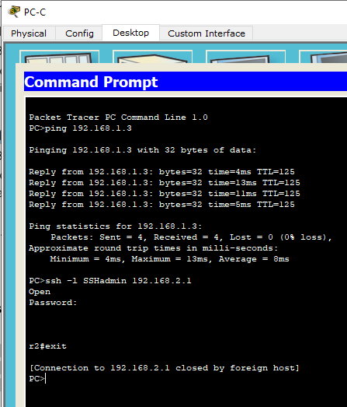
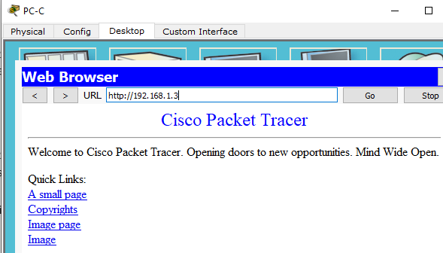

Part 2: Secure Access to Routers
Step 1: Configure ACL 10 on all routers to block all remote access to the routers except from PC-C. and Apply ACL 10 to ingress traffic on the VTY lines.
R1(config)#access-list 10 permit host 192.168.3.3
R1(config)#line vty 0 4
R1(config-line)#access-class 10 in

r2(config)#access-list 10 permit host 192.168.3.3
r2(config)#line vty 0 4
r2(config-line)#access-class 10 in

R3(config)#access-list 10 permit 192.168.3.3
R3(config)#line vty 0 4
R3(config-line)#access-class 10 in

Step 2: Verify exclusive access from management station PC-C.
- Establish an SSH session to 192.168.2.1 from PC-C (should be successful).
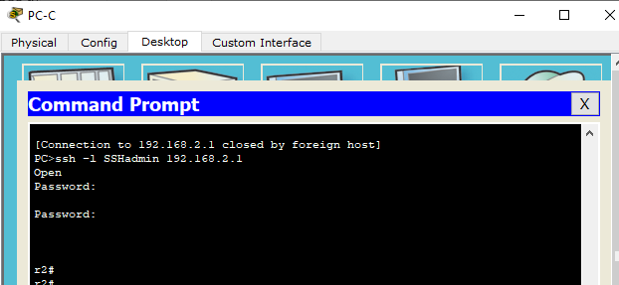

- Establish an SSH session to 192.168.2.1 from PC-A (should fail).
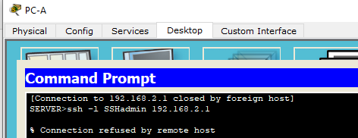

Part 3: Create a Numbered IP ACL 120 on R1
Step 1: Verify that PC-C can access the PC-A via HTTPS using the web browser.
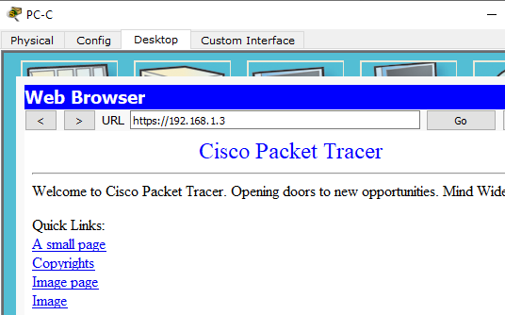
Step 2: Configure ACL 120 to specifically permit and deny the specified traffic.
R1(config)#access-list 120 permit udp any host 192.168.1.3 eq domain
R1(config)# access-list 120 permit tcp any host 192.168.1.3 eq smtp
R1(config)#access-list 120 permit tcp any host 192.168.1.3 eq ftp
R1(config)#access-list 120 deny tcp any host 192.168.1.3 eq 443
R1(config)#access-list 120 permit tcp host 192.168.3.3 host 10.1.1.1 eq 22

Step 3: Apply the ACL to interface S0/0/0.
R1(config)# interface s0/0/0
R1(config-if)#ip access-group 120 in

Step 4: Verify that PC-C cannot access PC-A via HTTPS using the web browser.
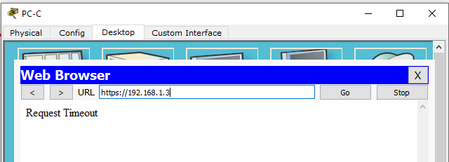

Part 4: Modify an Existing ACL on R1
Permit ICMP echo replies and destination unreachable messages from the outside network (relative to R1). Deny all other incoming ICMP packets.
Step 1: Verify that PC-A cannot successfully ping the loopback interface on R2.
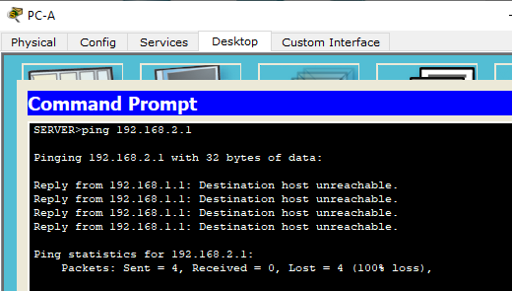
Step 2: Make any necessary changes to ACL 120 to permit and deny the specified traffic.
R1(config)# access-list 120 permit icmp any any echo-reply
R1(config)#access-list 120 permit icmp any any unreachable
R1(config)#access-list 120 deny icmp any any
R1(config)# access-list 120 permit ip any any

Step 3: Verify that PC-A can successfully ping the loopback interface on R2.
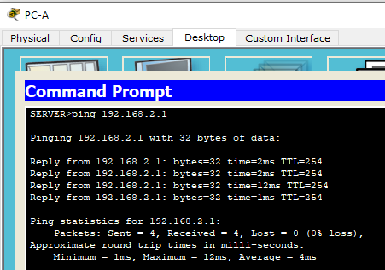
Part 5: Create a Numbered IP ACL 110 on R3
Deny all outbound packets with source address outside the range of internal IP addresses on R3.
Configure ACL 110 to permit only traffic from the inside network and Apply the ACL to interface G0/1.
R3(config)#access-list 110 permit ip 192.168.3.0 0.0.0.255 any
R3(config)#interface g0/1
R3(config-if)# ip access-group 110 in

Part 6: Create a Numbered IP ACL 100 on R3
On R3, block all packets containing the source IP address from the following pool of addresses: any RFC 1918 private addresses, 127.0.0.0/8, and any IP multicast address. Since PC-C is being used for remote administration, permit SSH traffic from the 10.0.0.0/8 network to return to the host PC-C.

Private address Range | Subet
10.0.0.0/8 to 10.255.255.255/8 | 10.0.0.0/8
172.16.0.0/12 to 172.31.255.255/12 | 172.16.0.0/12
192.168.0.0/16 to 192.168.255.255/16 | 192.168.0.0/16
Multicast address :Class D: 224.0.0.0 – 239.255.255.255

Step 1: Configure ACL 100 to block all specified traffic from the outside network. Apply the ACL to interface Serial 0/0/1.

R3(config)#access-list 100 permit tcp 10.0.0.0 0.255.255.255 eq 22 host 192.168.3.3
R3(config)#access-list 100 deny ip 10.0.0.0 0.255.255.255 any
R3(config)# access-list 100 deny ip 172.16.0.0 0.15.255.255 any
R3(config)#access-list 100 deny ip 192.168.0.0 0.0.255.255 any
R3(config)# access-list 100 deny ip 127.0.0.0 0.255.255.255 any
R3(config)#access-list 100 deny ip 224.0.0.0 15.255.255.255 any
R3(config)#access-list 100 permit ip any any
R3(config)# interface s0/0/1
R3(config-if)#ip access-group 100 in

Step 2: Confirm that the specified traffic entering interface Serial 0/0/1 is handled correctly.
- From the PC-C command prompt, ping the PC-A server. The ICMP echo replies are blocked by the ACL since they are sourced from the 192.168.0.0/16 address space.
